AI POWERED CROP DISEASE DETECTION AND RECOMMENDATION SYSTEM FOR SUSTAINABLE DEVELOPMENT
Conclusion, Future Scope and References
Department of Computer Science and Engineering, [COLLEGE NAME]
Batch C16 (CSE-C) · Academic year [ACADEMIC YEAR]
Table 1: Project team
S.No. | Student name | Roll number
1 | Pishke Vishal | 23K91A05J2
2 | Kyatham Nithisha | 23K91A05D1
3 | Mekala Tharun Kuruma | 23K91A05F1
4 | Nakka Sreenith | 23K91A05H0

Project guide: V Krishna Teja
Chapter and section numbers quoted in the text (for example Chapter 8 or Section 6.2) refer to the full project report, 17.Final Document. Figures and tables in this document are numbered from 1.

1. CONCLUSION

1.1 Summary
AgriVision turns a leaf photograph into a diagnosis card. A farmer signs in, chooses the crop, uploads a photograph and receives the most likely disease or 'healthy', a severity label, the three highest-scoring alternatives and chemical, organic and cultural treatment advice with prevention notes, for 38 classes of 14 crops. Every scan is stored, can be filtered, exported as CSV or PDF, deleted and summarised in a dashboard and in analytics. The interface works in English, Hindi and Marathi. The application is a React single-page application over a FastAPI service that imports the original Flask product unchanged, with one SQLite database; it starts with one command, answers a diagnosis request in a median of 23 ms on the same machine and passes 39 of 39 smoke checks.
The project also measured what the application can recognise. No trained network is installed, so the engine that runs is a colour and texture heuristic. On the 236 PlantDoc test photographs it names the correct class for 9.1 ± 1.0% of photographs when the crop is chosen and 1.3 ± 0.7% when it is not; the chance level is 36.0% and 2.6% respectively. The compact CNN of the training script reaches 12.0 ± 0.5%, and a reference MobileNetV2 with ImageNet weights reaches 50.3 ± 0.9% (macro-F1 0.490). The software is therefore complete as an application and incomplete as a diagnostic instrument.

1.2 Objectives achieved
The table below sets each objective of the batch document against what was delivered.
Table 2: Objectives against outcomes
Objective | What was delivered and measured | Status
1. Labelled dataset of healthy and diseased leaves | PlantDoc: 2,578 web-scraped field photographs, 28 classes, 13 crops, split 2,342 train / 236 test; not collected by the team. | Achieved (borrowed data)
2. Preprocess and augment for lighting, angle, background | Resize to 224 px and in-model flip, rotation, zoom and contrast augmentation in train.py; the shipped heuristic only resizes to 256 px. | Partly achieved
3. Train a CNN for specific disease categories | Compact CNN trained here: 12.0 ± 0.5% accuracy (3 seeds), under-fitting; MobileNetV2 reference 50.3 ± 0.9%. No network is installed in the application. | Trained, not accurate, not shipped
4. Map each disease to a treatment and fertiliser recommendation | All 38 classes return symptoms, severity and three treatments (chemical, organic, cultural) plus prevention. No fertiliser, yield or weather advice; not agronomist-validated. | Treatment achieved; fertiliser not implemented
5. Web interface with multilingual support | React application with 12 pages, history, exports, analytics; English, Hindi and Marathi for interface strings only (disease text stays English). | Web achieved; multilingual partly
6. Per-class accuracy and validation of recommendations | Per-class precision, recall and F1 and confusion matrices measured on 27 test classes; recommendations were not validated against agronomic guidance. | Accuracy measured; validation not done

1.3 Key findings
1. The shipped heuristic does not diagnose. Top-1 accuracy 9.1 ± 1.0% with the crop chosen (10.6% with the hash seed that run.bat sets), top-3 34.9 ± 1.6%, and 1.3 ± 0.7% with the crop left on 'general'. Healthy-versus-diseased accuracy 35.1 ± 0.9% is below the 61.9% obtained by always answering 'diseased'.
2. The displayed confidence carries no information. The mean displayed confidence is 95%, while top-1 is correct on only 14 % to 22 % of photographs in the confidence bins that occur, and the three displayed scores add up to more than 102 % on 82% of answerable photographs (largest sum 112%).
3. 32.2% of test photographs get no answer when the crop is chosen: ten of the engine's 19 crop keys (nine of the 18 offered in the web form) leave fewer than three candidate classes and the heuristic raises an error that the API reports as an unreadable image (defect D1).
4. The shipped CNN recipe under-fits and reaches 12.0 ± 0.5%. Training accuracy is only 22.2 ± 2.8%; the recipe that validates on the test folder gives 13.6% and a run without learning-rate decay 12.7%, so the cause is the model and the data size, not the schedule. The same script also mislabels the two grape classes during evaluation (defect D5).
5. Transfer learning is the realistic route on field photographs. MobileNetV2 reaches 50.3 ± 0.9% accuracy, 79.8 ± 1.4% top-3 and 88.8 ± 0.5% healthy-versus-diseased accuracy; a random forest on colour and texture features reaches 21.6%. The PlantDoc authors report 29.7 % for VGG16 on raw photographs and 44.5 % to 70.5 % on cropped leaves [4], so 50.3 ± 0.9% is in the expected range.
6. The application layer is sound but has security gaps. 51 checks, 46 pass, 5 reproduce defects; the defects are the default public signing secret (D3) and the absence of login rate limiting (D4), besides D1, D2 and D7.

1.4 Practical applications
• As a prototype for agricultural extension offices and student projects: the full path from photograph to advice, history and export is in place and runs on one CPU laptop.
• As a test bed for a real model: dropping plantdoc_cnn.h5 and labels.json into agrivision/models/ switches the engine, and the experiment script gives a repeatable way to compare candidates.
• As a disease reference: the disease guide with symptoms, lifecycle and treatments for 38 classes is usable without any model.
• Not as a decision tool for spraying: advice must be confirmed by an agricultural officer, as the application itself states on every result.

1.5 Known limitations
The limitations are listed with evidence in Chapter 7 and in the document on scope and limitations. In short: no accurate model in the product, 50 % at best in the reference experiment; seven defects, of which D1 and D5 matter most; no fertiliser, yield or weather advice; unvalidated advice; translated interface but not translated advice; PlantDoc only, no own photographs, no field trial or user study.
The comparison of the engines and the healthy-versus-diseased recall behind the key findings are shown below.
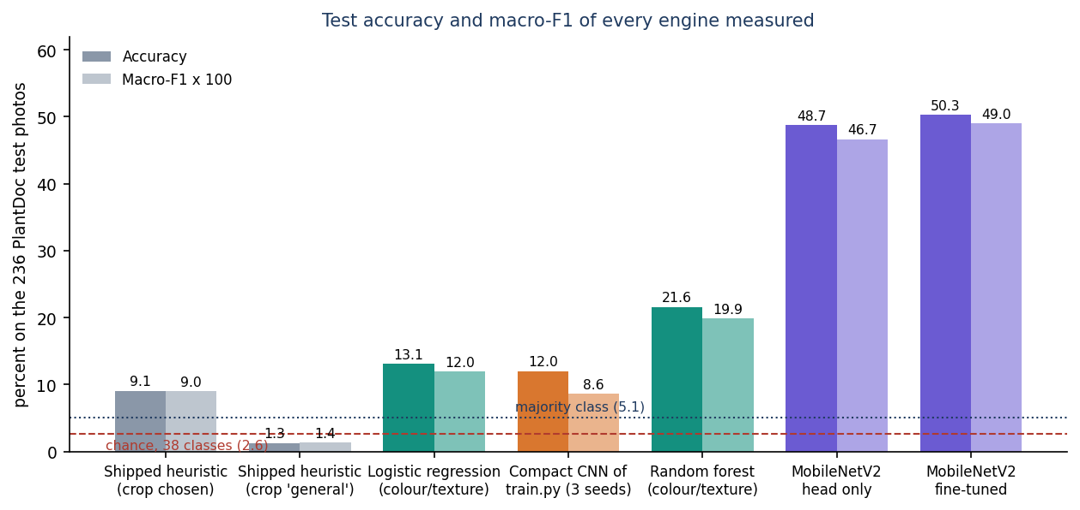
Figure 1: Test accuracy and macro-F1 of every engine measured on the PlantDoc test split.
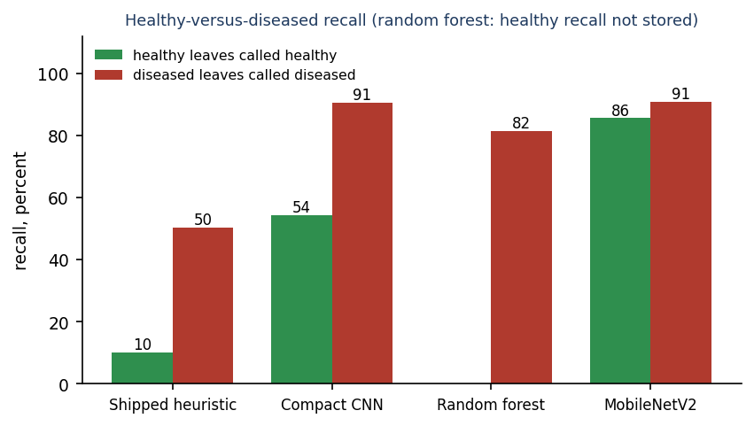
Figure 2: Healthy-versus-diseased recall of the engines on the PlantDoc test split.

2. FUTURE SCOPE
The measurements of Chapter 8 define the order of work: first make the recognition trustworthy, then widen what the application advises on, then prepare it for more users. Each item below is tied to a limitation or defect of this report.

2.1 Improvements to the diagnosis
The recognition quality is the weakest part of the project, so improvements start there. The first step costs little: a trained network that is already better than the heuristic exists in the experiment script.
1. Ship a trained network. Fine-tune MobileNetV2 (2.29 million parameters, 89 ms per image on this CPU) or EfficientNet [14] on more data, save it as plantdoc_cnn.h5 with labels.json and let try_load_model() pick it up. The expected level on this data is 50 % to 70 %, so the interface must keep its warning.
2. Fix defects D1 to D7. Guard _heuristic_predict for crops with fewer than three candidates (or pad the candidate list); sum the three displayed scores to 100 % or hide them; require AGRIVISION_SECRET at start-up; add rate limiting to login; correct the class-name list and the validation split in train.py; remove the constant latency padding.
3. Crop first, then classify. PlantDoc authors obtain their best results after cropping to the leaf; a leaf detector or a simple segmentation step would remove most background noise.
4. Calibrate and abstain. Replace the saturating score with calibrated probabilities (temperature scaling) and return 'not sure, ask an officer' below a threshold, evaluated on a held-out set.
5. Explain the decision. Grad-CAM [17] maps on the leaf photograph would show the farmer which region drove the answer; the nested-backbone limitation of the shipped Grad-CAM helper has to be solved first.
6. Collect own photographs. Field photographs from the target region, labelled by an agronomist, are needed to measure real accuracy; the base paper's idea of generating foliage images [1] could extend a small set but is a research task of its own.

2.2 Additional features
The batch abstract proposes several services that this implementation does not contain. They are listed here in the order in which they would add most for a farmer.
• Fertiliser advice: nutrient-deficiency classes and dose tables per crop and growth stage, reviewed by an agronomist.
• Yield prediction and weather: rainfall, temperature and soil data (the batch abstract proposes OpenWeatherMap) to give spray timing and expected yield; none of this exists yet.
• Translation of advice: treatment, symptoms and prevention text in Hindi, Marathi and further languages; today only about 44 interface strings are translated.
• Voice and low-literacy input: speech output of the diagnosis and voice-driven navigation.
• Administrative dashboard: user management, disease trends by region and model monitoring for an extension office.
• Multiple diseases and foliage images: several leaves or a whole canopy in one photograph, as in the base paper.

2.3 Scalability and deployment
The present deployment is one process on one PC, which suits a demonstration. A service for an extension office needs the following changes.
• Move from SQLite to PostgreSQL and the image folder to object storage when more than one server is used.
• Containerise the API and the web build, serve the web build from a static host or reverse proxy rather than the Vite server, and terminate TLS.
• Add rate limiting, account lock-out, password reset and token refresh, and keep the signing secret in a secret store.
• Run load tests: the current latency figures (median 23 ms, 95th percentile 82 ms) are for one client on one PC.
• Offline use: convert the network to TensorFlow Lite and cache the disease guide so that a phone can diagnose without a connection.

2.4 Further research
Beyond engineering, the experiments raise questions that a longer project could answer.
• Domain adaptation from laboratory images (PlantVillage) to field photographs, where the literature reports large drops.
• Few-shot learning for rare diseases (the PlantDoc spider-mite class has two training photographs).
• Severity estimation from lesion area instead of a fixed per-disease label.
• Evaluating whether the generated foliage images of the base paper improve diagnosis of the crops covered here.
• A user study with farmers on whether the advice is understood and acted on.

3. REFERENCES
[1] N. Pakka, T. Wilkerson, L. Chen and N.-F. Tzeng, "Foliagen: Framework for crop foliage image generation from individual leaf images," IEEE Access, 2026, doi: 10.1109/ACCESS.2026.3727421.
[2] S. Sherifi, E. Rustemi, S. Ismaili, E. Rufati and F. Idrizi, "A compact and efficient 1.251 million parameter machine learning CNN model PD36-C for plant disease detection: A case study," arXiv:2604.11332, Apr. 2026.
[3] S. Kanakala and S. Ningappa, "Detection and classification of diseases in multi-crop leaves using LSTM and CNN models," J. Innovative Image Processing, vol. 7, no. 1, pp. 161-181, Mar. 2025, doi: 10.36548/jiip.2025.1.008.
[4] D. Singh, N. Jain, P. Jain, P. Kayal, S. Kumawat and N. Batra, "PlantDoc: A dataset for visual plant disease detection," in Proc. 7th ACM IKDD CoDS and 25th COMAD, Hyderabad, India, 2020, pp. 249-253; arXiv:1911.10317.
[5] D. P. Hughes and M. Salathe, "An open access repository of images on plant health to enable the development of mobile disease diagnostics," arXiv:1511.08060, 2015.
[6] S. P. Mohanty, D. P. Hughes and M. Salathe, "Using deep learning for image-based plant disease detection," Frontiers in Plant Science, vol. 7, Art. no. 1419, 2016.
[7] K. P. Ferentinos, "Deep learning models for plant disease detection and diagnosis," Computers and Electronics in Agriculture, vol. 145, pp. 311-318, 2018.
[8] J. G. A. Barbedo, "Factors influencing the use of deep learning for plant disease recognition," Biosystems Engineering, vol. 172, pp. 84-91, 2018.
[9] M. Sandler, A. Howard, M. Zhu, A. Zhmoginov and L.-C. Chen, "MobileNetV2: Inverted residuals and linear bottlenecks," in Proc. IEEE/CVF Conf. Comput. Vision Pattern Recognit. (CVPR), 2018, pp. 4510-4520.
[10] F. Chollet, "Xception: Deep learning with depthwise separable convolutions," in Proc. IEEE Conf. Comput. Vision Pattern Recognit. (CVPR), 2017, pp. 1251-1258.
[11] S. Ioffe and C. Szegedy, "Batch normalization: Accelerating deep network training by reducing internal covariate shift," in Proc. 32nd Int. Conf. Machine Learning (ICML), 2015, pp. 448-456.
[12] D. P. Kingma and J. Ba, "Adam: A method for stochastic optimization," in Proc. 3rd Int. Conf. Learning Representations (ICLR), 2015; arXiv:1412.6980.
[13] J. Deng, W. Dong, R. Socher, L.-J. Li, K. Li and L. Fei-Fei, "ImageNet: A large-scale hierarchical image database," in Proc. IEEE Conf. Comput. Vision Pattern Recognit. (CVPR), 2009, pp. 248-255.
[14] M. Tan and Q. V. Le, "EfficientNet: Rethinking model scaling for convolutional neural networks," in Proc. 36th Int. Conf. Machine Learning (ICML), 2019, pp. 6105-6114.
[15] K. He, X. Zhang, S. Ren and J. Sun, "Deep residual learning for image recognition," in Proc. IEEE Conf. Comput. Vision Pattern Recognit. (CVPR), 2016, pp. 770-778.
[16] K. Simonyan and A. Zisserman, "Very deep convolutional networks for large-scale image recognition," in Proc. 3rd Int. Conf. Learning Representations (ICLR), 2015.
[17] R. R. Selvaraju, M. Cogswell, A. Das, R. Vedantam, D. Parikh and D. Batra, "Grad-CAM: Visual explanations from deep networks via gradient-based localization," in Proc. IEEE Int. Conf. Comput. Vision (ICCV), 2017, pp. 618-626.
[18] L. Breiman, "Random forests," Machine Learning, vol. 45, no. 1, pp. 5-32, 2001.
[19] F. Pedregosa et al., "Scikit-learn: Machine learning in Python," J. Mach. Learn. Res., vol. 12, pp. 2825-2830, 2011.
[20] M. Abadi et al., "TensorFlow: A system for large-scale machine learning," in Proc. 12th USENIX Symp. Operating Systems Design and Implementation (OSDI), 2016, pp. 265-283.
[21] M. Gehlot, R. K. Saxena and G. C. Gandhi, "Tomatovillage: A dataset for end-to-end tomato disease detection in a real-world environment," Multimedia Systems, vol. 29, no. 6, pp. 3305-3328, 2023.
[22] E. Moupojou, A. Tagne, F. Retraint, A. Tadonkemwa, D. Wilfried, H. Tapamo and M. Nkenlifack, "FieldPlant: A dataset of field plant images for plant disease detection and classification with deep learning," IEEE Access, vol. 11, pp. 35398-35410, 2023.
[23] Q. Wu, X. Ma, H. Liu, C. Bi, H. Yu, M. Liang, J. Zhang, Q. Li, Y. Tang and G. Ye, "A classification method for soybean leaf diseases based on an improved ConvNeXt model," Scientific Reports, vol. 13, no. 1, Art. no. 19141, 2023.
[24] A. Abbas, S. Jain, M. Gour and S. Vankudothu, "Tomato plant disease detection using transfer learning with C-GAN synthetic images," Computers and Electronics in Agriculture, vol. 187, Art. no. 106279, 2021.
[25] "Leaf based crop disease detection," Int. J. Research Publication and Reviews, 2026. [Listed in the batch literature survey; authors and content not verified.]
[26] "Explainable CNN framework for accurate crop disease detection using plant leaf images," Scientific Reports, 2026. [Listed in the batch literature survey; authors and content not verified.]
[27] "AI-driven plant disease detection: Leveraging deep learning for accurate plant disease detection from leaf images," Int. J. Science and Research (IJSR), 2024. [Listed in the batch literature survey; authors and content not verified.]
[28] "Plant leaf disease detection: Review report," Int. J. Science and Research (IJSR), 2025. [Listed in the batch literature survey; authors and content not verified.]

